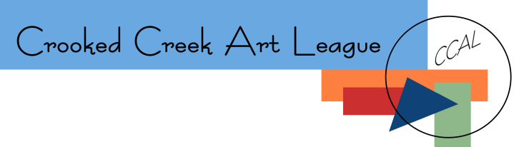
Membership Application/Renewal Form

Name
Address
City _______________________________________ State ________________ Zip
Phone(s) home _________________________ cell _______________________work
Email
Personal Website
Preferred Medium(s)
How did you hear about us?

Please indicate your membership level
 | Membership Level | Amount
 | Patron Membership | $50
 | General Membership | $25
 | Associate Membership | $25
 | Family Membership | $50
 | Student Membership | $20

A great way to get the most out of your membership is to get involved. Please let us know how you might be willing and able to provide assistance within the league.

(Check all that apply)
 | Refreshments |  | Workshops |  | Greeter
 | Presenters |  | Juried Show |  | Social Events
 | Finance |  | Minutes |  | Public Galleries
 | Website |  | Social Media (FB/IG) |  | Publicity
 | Fund Raising |  | Community outreach |  | Technical setup
 | Special projects |  | Membership |  | Other ___________________

Three ways to Join/Renew:
Apply and pay online at crookedcreekart.org/join-or-renew | Submit this completed form and your payment in person at any CCAL meeting or event. | Mail this completed form and your payment to:  Jean Kirkley  CCAL Membership Chair  315 Silver Wood Lane  Lexington, SC 29072

Thank you for your support of CCAL and the arts.
We look forward to welcoming you to the league!

Form updated 09/04/2022 | For Internal Use Only:  Date Paid __________________ Amount Received ________
CCAL Membership Application/Renewal
Crooked Creek Art League (CCAL) is located in Chapin, South Carolina. We have over 100 members, including professional and amateur artists and artisans - painters of all mediums, photographers, sculptors and mixed media artists. All are welcome. We have joined together to The purpose of the league is to encourage and support new and established artists, to educate and encourage each other’s work as well as to help grow the visual art in our community by offering artists avenues to improve skills, display and sell art, and to socialize and network with art supporters. Membership runs from September - August of each year.
Annual Membership Levels:
- General membership - $25
- Associate membership - $25 (out of state members)
- Patron membership - $50
- Family (up to four household members) - $50
- Students - $20
Benefits of General Membership include:
- Eligibility to enter our annual juried exhibit each year (Members in Good Standing* only, * Paid their dues by Dec. 31 & attended 3 meetings in the year leading to the show (March - February))
- Eligibility to enter our Still Hopes juried exhibit, annual May contest and non-juried Library Exhibitions (all artists)
- Displaying your artwork in numerous CCAL public galleries in partner locations
- Advance entry and reduced entry fees for workshops and seminars
- Meeting and exchanging creative ideas with other artists
- Promoting your artwork within CCAL and through our website and events
- Receiving news of upcoming art related events
- Enjoying and learning from guest presenters at monthly meetings
- Enjoying social events with fellow artists (Christmas Party, End of Year Party)
- Receiving a monthly newsletter from CCAL President
- Option to show and promote your art in an online personal artist gallery on this website (additional $25 fee)
* Any resident of a state other than South Carolina may join the League as an Associate Member and have all the benefits of membership except the right to vote.
In addition to all the above, Patron Membership includes:
- Free participation in an online artist gallery on this website
- Free link from CCAL website to your personal website
- Special recognition on the membership directory, on the website, and in the Annual Juried Show & Sale
Family membership includes all the benefits of general membership for up to 4 people within a single family household. Optional Website gallery pages are available for $25 per family member.
Student membership includes all the benefits of general membership at a discounted rate for any high school or college student. Optional Website gallery pages are available for $25. A valid student ID is required for application or renewal.

